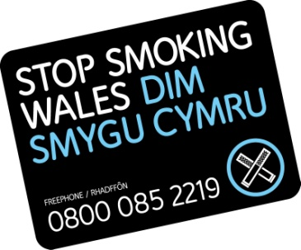
Free treatment and help to quit with Stop Smoking Wales


Sessions are held in:
Caerphilly
Wesley Hall Blackwood
Bargoed Community Centre
Twyn Centre Caerphilly
Lansbury Park Surgery
Newbridge Memo
Risca- Wellspring Medical Centre
Gelligaer Surgery
Court House Medical Practice
Ty Bryn Surgery

Blaenau Gwent
Abernant Surgery
Brynmawr LAC
Cwm Health Centre
Ebbw Vale LAC
Tredegar Library
Llanhilleth Surgery

Torfaen
Abersychan Surgery
Blaenavon- Carregwen Surgery
Cwmbran- The Congress Theatre and Cwmbran Library
Trevethin Life Station
Pontypool Leisure Centre

Monmouthshire
Chepstow Hospital

Caldicot Library

Nevill Hall Hospital

Newport
Alway Community Association
The Riverfront Theatre
Asda Duffryn

*Areas may be subject to change. Contact 0800 085 2219 for latest information
For more information or to book an appointment with our friendly advisor, contact us on: 0800 085 2219
www.dimsmygucymru.com / www.stopsmokingwales.com (to book online)

facebook.com/dimsmygucymru @dimsmygucymru

facebook.com/stopsmokingwales @stopsmokingw

